Monsanto
SharePoint Shared Services
Application Handbook
1.0
App 972-Advance Request



 | Prepared by / Last Updated By | Reviewed by | Approved By
Name | Manoj Kumar R | Vijay S | Vijay S
Role | Support Team
Signature
Date | 8/9/2021 | 8/10/2021 | 08/10/2021

Table of Contents
1.0 Introduction 4
1.1 Purpose 4
1.2 Intended Audience 4
1.3 Definitions and Acronyms -- N/A 4
2.0 Scope of Maintenance operations 4
3.0 Application Overview 4
3.1 Functional Overview 4
3.2 Module Description 5
3.3 User Roles & Privileges 7
3.4 Assumptions, Dependencies and Risks 7
3.5 Non-Functional Requirements 7
3.6 Drawbacks/ Constraints/ Known Issues 8
4.0 Application Architecture 8
4.1 Hardware Architecture 8
4.2 Software Architecture 8
5.1 User Characteristics 9
5.2 External Interface Specifications 9
5.3 Performance Requirements 9
5.4 System Recovery Procedures 9
5.5 System Attributes 9
5.6 System Installation and patch Management 9
6.0 Specifications 10
6.1 Application Categorization 10
6.2 Application Component Inventory 10
6.3 User Authentication Scheme 10
6.4 Scheduled Tasks/ Batch Process 10
6.5 Process Flow 11
6.6 Program flow 18
6.7 Data flow 19
6.8 Folder Structure 19
6.9 Configuration Information 19
6.10 Application Interfaces 19
6.11 Application Repository 19
6.12 Application Environment 19
7.1 Third Party Components 23
7.2 Custom Frameworks 23
7.3 Client Information 23
7.4 Development and Build Utilities 23
8.1 Accessing the Application 23
8.2 Support Schedule 23
8.3 Application Build & Deployment Strategy 24
8.4 Support and Escalation Contact 24
8.5 Change Management & Rollout Strategy 24
8.6 Coding Standards 24
8.7 Existing Support Process 24
8.8 Existing Service Level Agreements 24
8.9 Frequently Occurring Issues & Remedies 24
8.10 Application Monitoring Details 25
8.11 Vendor Support Agreements 25
10.0 References 25
11.0 Change Log 26

Introduction

Purpose
The objective of this project is to automate the Advance Request raised by the employees for the official events.

Intended Audience
The intended audience for this document is
o Cognizant Development and support Team members
o Cognizant QA Team Members
o Monsanto Platform lead

Definitions and Acronyms -- N/A

Scope of Maintenance operations
The scope of maintenance includes L2 and L3 support for the application.
Support
- Incidents
- Work orders
- Minor enhancements
- Change Management
- Problem Management

Application Overview

Functional Overview
This site is used in India region. An employee, Vendor or travel related advance payment request can be raised through this application. Necessary approvals from different level of management will be generated automatically using workflows.
System should verify whether its Employee advance, vendor advance and Travel Advance and need to process for approvals. Also, system need to verify the mode of payment and should redirect the workflow to get necessary approvals. DOA need to be considered when taking the financial controller or other approval process.
Note: Currently existing application is in use, the enhanced version of Advance Request is NOT in use.
UI advance request form and workflow. Three types of advance request Employee advance, vendor advance and Travel Advance. Two types of payment options , Manual Check or EDI payment

3.2 Module Description
Module wise feature breakup:
Advance request Module
- Request form (UI)
- Workflow for approvals
- Consideration of DOA for approvals
- Employee information from Employee List.
- Approval group is created in SharePoint using AD users.
- Report
Application Link: http://sp-appl-us.azure.cnb/sites/270114/advancerequest/default.aspx

Once approved by Approver –
APPROVED or REJECTED
Once approved
- If it is Manual check, then email will be sent to Requester for information; Entity Controller/Finance Lead for further approval
Once approved by Entity Controller/Finance Lead, then email will be sent to CFO for further approval, and Finance Controller for Information.
Once approved by CFO – email will go to Treasury team for cheque preparation, Requestor and Approvers (Dept Head & Finance controller) for Information
- If it is EDI payment ( Vendor Advance, Travel Advance )– then email will be sent to Requester for information; Entity Controller/Finance Lead for further approval
Once approved by Entity Controller/Finance Lead, email will go to SSC for DP request in SAP; Requestor and Approvers (Dept Head & Finance controller) for Information

c. If it is EDI payment - Employee Advance-(Permanent & Temporary ) – then email will be sent to Requester for information, Treasury Lead for further approval
Once approved by Treasury Lead, email will go to SSC for DP request in SAP; Requestor and Approvers ( Dept Head & Finance controller) for Information

SI.No | Action | Result | Workflow Status
1 | Advance request raised by user | Request is generated and mail notification sent to approver | Request Created.Pending approval
2 | Approver Rejects the request | Advance request cancelled and mail notification sent to requestor. | Rejected
3 | Approver Approves the request | 1.If mode of payment is Manual check then the mail notification sent to Entity controller/Finance Lead. EC/FC is chosen depending on DOA and requested advance amount. 2.If mode of payment is EDI and type is Employee Advance-(Permanent & Temporary ) – then email will be sent to Requester for information; Treasury Lead for further approval. 3. If mode of payment is EDI and type is Vendor Advance, Travel Advance – then email will be sent to Requester for information; Entity Controller/Finance Lead for further approval | Pending for EC/FC /TL approval
4 | Entity controller / Finance lead rejects request | Request closed and mail notification sent to requestor | Rejected by EC/FC
5 | Entity controller / Finance lead approves request(Manual check) | Mail notification sent requestor for information and to CFO for further approval. | Pending approval from CFO
6 | CFO rejects request | Request closed and mail notification sent to requestor | Rejected by CFO
7 | CFO approves request | Email will go to Treasury team for cheque preparation, Requestor and Approvers (Dept Head & Finance controller) for Information | Approved
8 | Treasury lead Rejects request | Mail notification sent to requestor and approver for information. | Rejected
9 | Treasury lead approves request (EDI & Employee advance) | Email will go to SSC for DP request in SAP; Requestor and Approvers ( Dept Head & Finance controller) for Information | Approved
10 | EC/FL rejects request | Mail notification sent to requestor and approver for information. | Rejected
11 | EC/FL approves request (EDI & Vendor/Travel advance) | email will go to SSC for DP request in SAP; Requestor and Approvers (Dept Head & Finance controller) for Information | Approved

3.3 User Roles & Privileges
Requestor – User able to raise advance request in form.
Reporting Manager, Entity Controller, Reporting Manager, Payroll Executive, Finance controller, SSC Group Members – Based on the Advance Type , Approver have to do the Approval.

3.4 Assumptions, Dependencies and Risks
Assumptions

- Development tools and environment will be provided by Monsanto.
- Hardware and Software (operating environment) will be provided by Monsanto.
- Employee data made available time to time for development, testing and production.
- Business Users are available for any requirement clarifications.
- Source code management tools will be provided by Monsanto. In case not provided, it’s a Risk.

Dependencies

- These applications will be totally dependent on Employee data.(database and AD)

3.5 Non-Functional Requirements
Performance Requirements

Database and application is to be designed to provide optimal execution performance with high volume of data.

Safety & Security Requirements
Only authenticated and authorized Users can access the application and application features.
Software Quality Attributes

Availability: To enable high availability, application will be web interfaced.
Correctness: One to two iteration of System testing and User acceptance testing will be done to ensure the correctness of the application.

3.6 Drawbacks/ Constraints/ Known Issues
N/A

Application Architecture

Hardware Architecture

N/A

Software Architecture
N/A
- System Requirements
Hardware Requirements
Processor: P 4, 600MHZ or More
RAM: 1GB or more

Software Requirements
Operating system: Windows Server 2003 with latest service packs
Web server: Internet Information Services 6.0
Framework: .NET 2.0
Browser: Internet Explorer 6.0 and further versions

User Characteristics
N/A
.

External Interface Specifications
User Interfaces

User interface for this software application will be SharePoint portal page.

Hardware Interfaces

Not Applicable.

Software Interfaces

This application will interface with Web service, Oracle Database

Communications Interfaces

Communication Protocols required for the system.
SMTP – For mailing

Performance Requirements
Users should be able to access the site and upload documents simultaneously.

System Recovery Procedures
Back Up and restore using power shell command control handled by US Azure team.

System Attributes
The system is stable and easily maintainable. All the configuration settings are stored in the web config file and all the service accounts are stored in a tool called Keepaas.

System Installation and patch Management
Installation and Patch Management are handled by US Azure support team.
POC: stan.gallagher@bayer.com

Specifications

Application Categorization
<Provide environment details for the application. A link to Application Inventory may also be provided. Provide details based on whether the application is online / batch>

Online Application details
Source | Description | Frequency

Batch

Application details
<Provide details for batch applications>
Job Name | Reference (Data Set / Table / Reports) | Source | Description | Frequency

Application Component Inventory
N/A

User Authentication Scheme
Windows Authentication NTLM.

Scheduled Tasks/ Batch Process
Please refer to the below link.

Process Flow
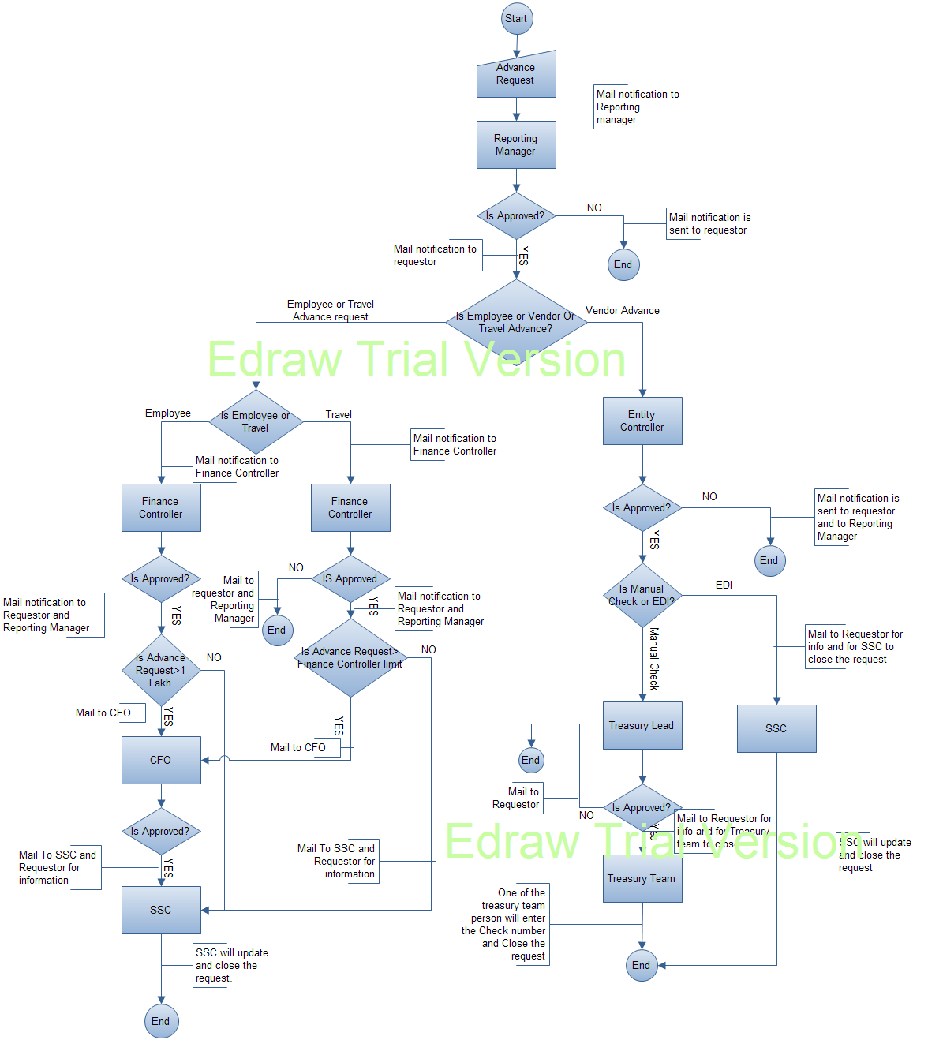

Enhanced Version

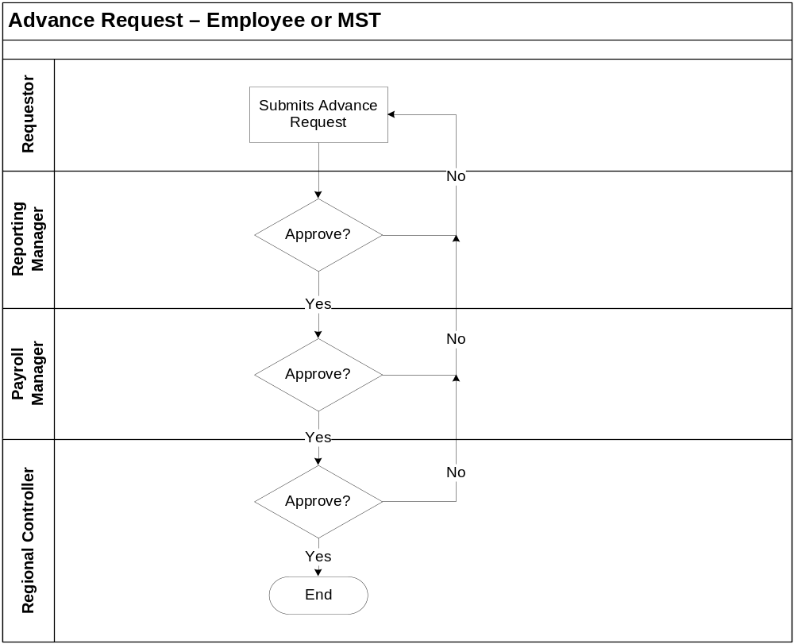

Process (Employee or MST request):-

- Requestor initiated the process by creating an advance request, attaching the required documents and submitting the request in the online tool
- As described above, the request follows the above approval workflow and gets approved by Reporting Manager, Payroll Manager and Regional Controller
- If the request is rejected at any level, the request will flow back to requestor who can resubmit the request after making the required changes
- Once approved by Regional Controller team, the request is closed & the requestor is informed about its completion through an email notification. Regional Controller will have ‘Close request’ button to close the request.
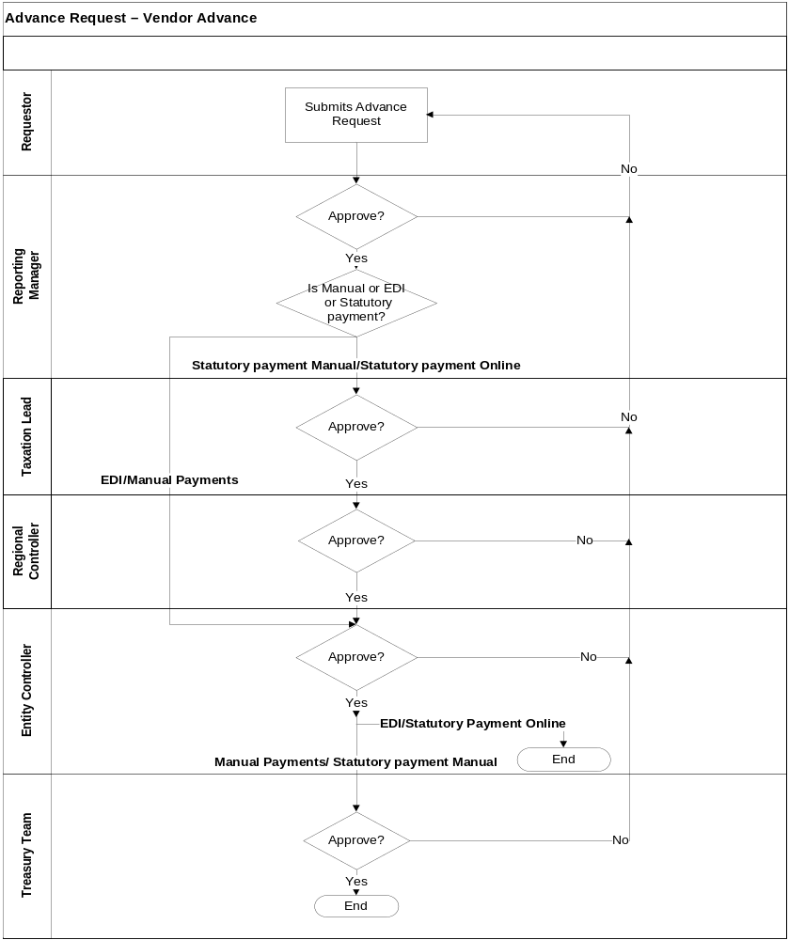

Process (Vendor Advance):-

- Requestor initiated the process by creating an advance request, attaching the required documents and submitting the request in the online tool
- The request is then forwarded for Reporting Manager’s approval
- Once approved by Reporting Manager, if the payment type is Statutory payment Manual/Statutory payment Online, then the request is forwarded for Taxation Lead, Regional Controller and Entity Controller’s approval
- For EDI/Manual Payments payment type, the request is directly forwarded to Entity Controller for approval
- Post Entity Controller’s approval, the request is forwarded to Treasury team for approval and closure of Manual Payments/ Statutory payment Manual request type.
- EDI/Statutory payment Online request types are closed by Entity Controller after their approval
- If the request is rejected at any level, the request will be redirected to requestor who can resubmit the request after making the required changes, which will reinitiate the workflow .The changes made by requestor, should be highlighted in yellow color.
- Once the request is closed, the requestor is informed about its completion through an email notification
- For Vendor Advance, last level will only have ‘Approve’ button instead of ‘Close Request’ button

Exception Workflow (Statutory payment Manual & Statutory payment Online)
- If a request is raised for Statutory payment Manual or Statutory payment Online by a designated set of users, the workflow will skip Reporting Manager’s approval and will directly be forwarded to the Taxation lead’s approval and will thus follow the below workflow depending upon Manual/Online.
- Manual:

Requestor - > Taxation Lead - > Regional Controller - > Entity Controller - > Treasury
- Online:

Requestor - > Taxation Lead - > Regional Controller - > Entity Controller

- The below are the attributes of the control activities :
Name | Description | Input type | Business Rule(s)
Requestor Name | This field displays the name of the requestor | System driven | System to display the log in user name
Company Code | User should select the company code from the following dropdown  - 1265 – MIL  - 1266 – MHPL  - 1269 – MMB  - 1276 – MIIPL  - 1281 – MHPL Bangladesh | Dropdown | User should be able to select 1 option from the available options
Amount | User should select the currency from the dropdown and enter the amount in the text box | Dropdown, Numeric | User should be able to select 1 option from the available options and enter amount in textbox
Department | This field displays the department name of the user | Text | System to display the log in user department name
Advance Type | User should select the type of advance request from the following dropdown  - Employee Advance  - Vendor Advance  - MST | Text | User should be able to select 1 option from the available options
Type | This field displays the sub type of selected advance request. For Employee Advance & MST request, the Type would be ‘EDI’. For Vendor Advance request, the user should select the type from the following dropdown:  - Manual Payments  - EDI  - Statutory payment Manual  - Statutory payment Online | Text | System to display the type as ‘EDI’ if Advance type selected is Employee Advance or MST. User should be able to select 1 option from the available options if Vendor Advance is selected
Employee Code | This field displays the employee code of the requestor | Text | System to display the employee code of the user if Advance type selected is Employee Advance or MST
Request Date | This field displays the date of submission of request | System driven | System to display the current date
Imprest Type | User should select the type of Imprest from the following dropdown options  - Temporary Imprest  - Permanent Imprest | Dropdown | System to display this field if Advance type selected is Employee Advance or MST
Opening Balance | User to enter the opening balance amount | Numeric | System to display this field if Advance type selected is Employee Advance or MST
Reason | User should enter the reason for raising the advance request | Text
Approver Name | This field displays the name of the requestor’s approver | Auto generated | System to display the log in user’s approver name
Declaration for FCPA | User should mention their declaration for FCPA, if required for the request.  For Vendor Advance request, the user should select an option from the below dropdowns:  - FCPA required  - FCPA not required | Text |   Attached text should be displayed in the text box as per the Advance Request type selected by the user. A checkbox with the text “I Agree” should be inserted next to the text box.
Vendor Code | User must enter the Vendor code if the Advance Type selected is Vendor Advance | Numeric | System to display this field if Advance type selected is Vendor Advance
Description | User can provide information about the advance request if the Advance Type selected is Vendor Advance | Text | System to display this field if Advance type selected is Vendor Advance
Reference (PO/Invoice) | User can provide the reference information – PO/Invoice if the Advance Type selected is Vendor Advance | Text | System to display this field if Advance type selected is Vendor Advance
Approval Document | User can attach documents required for approval |  | System to display this field if Advance type selected is Vendor Advance

- Comments should be mandatory for all approvals and rejections
- Audit trail section should be maintained for all requests and any changes done in the request should be tracked in this section
- A Report section should be included in the tool, which will allow users to generate report for all the advance requests. Report will have following filters, with an option of selecting ‘All’ in all the filters:-
- Company code
- Advance Type
- Payment Type
- Date range

Program flow
N/A

Data flow
N/A

Folder Structure
\\eagle\specialized_services\$Sharepoint_Dev\public\Internal\SPApps\globalcommercial\workflows

Configuration Information
- No Service Accounts for Advance Request Application
- Configuration settings and passwords are stored in web config file.

Application Interfaces
<Use the table below to detail the application interfaces as captured in the Due Diligence Questionnaire>
Type (Online / Batch) | User Interface | Hardware Interface | Software Interface | Communication Interface
Online | SP Appl-Azure |  | Employee list | http://sp-appl-us.azure.cnb/sites/270114  /advancerequest/Lists/Employees/EmployeeList.aspx

Application Repository
https://github.platforms.engineering/BayerSharepoint/AdvanceRequestWorkflow

Application Environment
Test --- http://qa-sp-appl-us.azure.cnb/sites/270114/advancerequest/default.aspx
Production -- http://sp-appl-us.azure.cnb/sites/270114/advancerequest/default.aspx

Advance Request Page

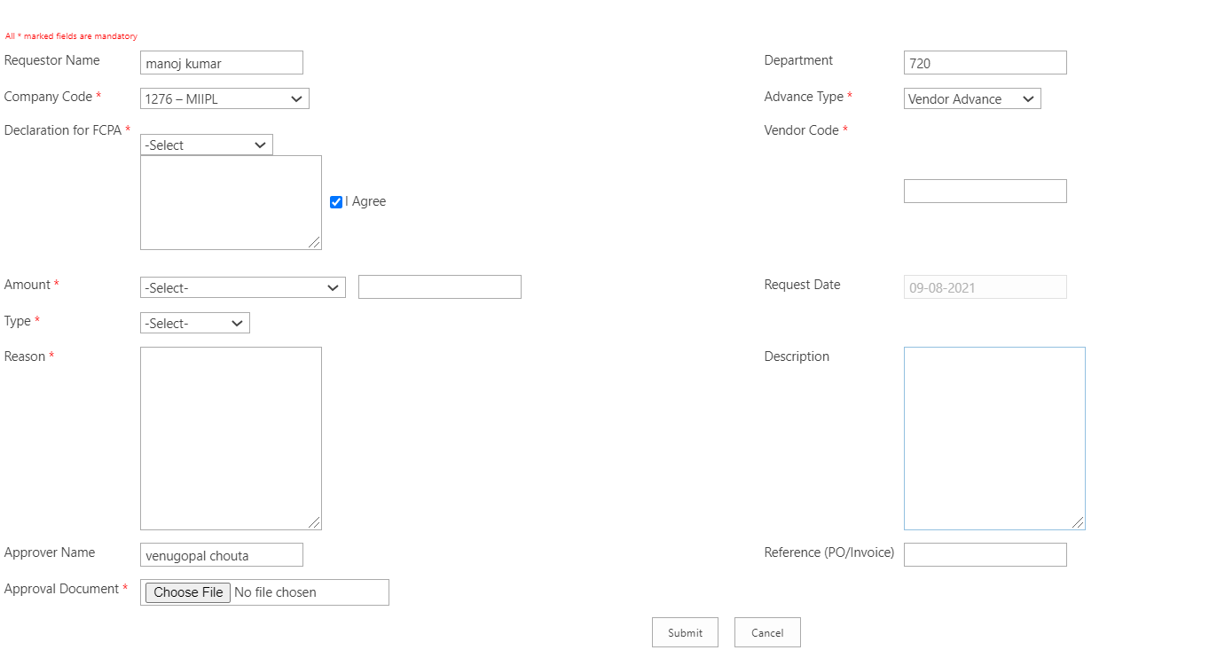

Enhanced Version
After Submission of the request the form is presented as shown below
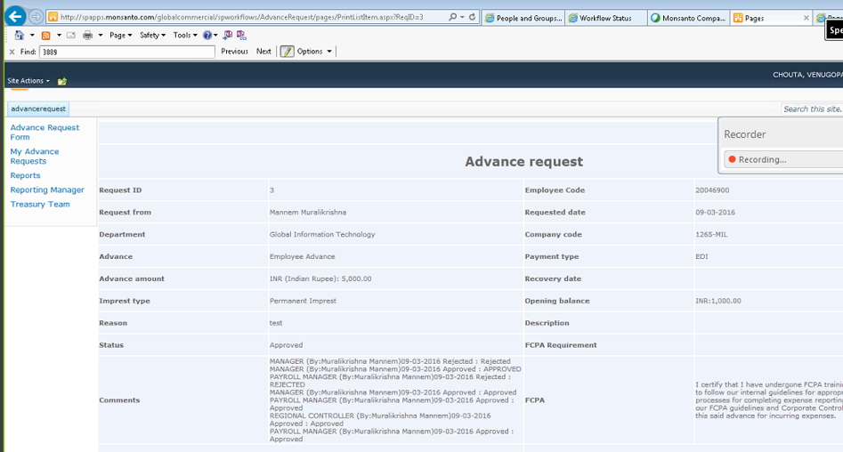
In the enhanced version the changed fields are colored so that the approver can know what the changed fields are. The picture is shown below.
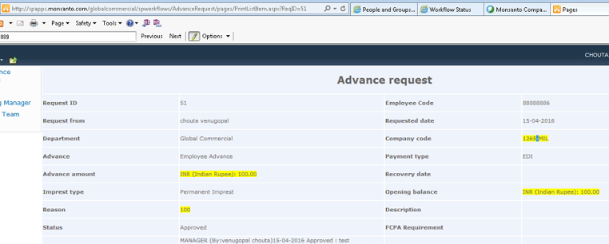

Requestor - offline(Manual / SPM) | Requestor - online (EDI / SPO) | Exception users -Offline(Manual / SPM) | Exception users -online (EDI / SPO)
Top of Form  Task Created to Manager  Bottom of Form | Top of Form  Task Created to Manager  Bottom of Form
MANAGER – Approved | MANAGER - Approved
Task Created to Taxation Lead | Task Created to Taxation Lead | Top of Form  Task Created to Taxation Lead  Bottom of Form | Top of Form  Task Created to Taxation Lead  Bottom of Form
TAXATION LEAD – Approved | TAXATION LEAD - Approved | TAXATION LEAD - Approved | TAXATION LEAD - Approved
Task Created to Regional Controller | Task Created to Regional Controller | Task Created to Regional Controller | Task Created to Regional Controller
REGIONAL CONTROLLER - Request Closed | REGIONAL CONTROLLER - Request Closed | REGIONAL CONTROLLER - Request Closed | REGIONAL CONTROLLER - Request Closed
Task Created to Entity Controller | Task Created to Entity Controller | Task Created to Entity Controller | Task Created to Entity Controller
ENTITY CONTROLLER – Approved | ENTITY CONTROLLER - Approved | ENTITY CONTROLLER - Approved | ENTITY CONTROLLER - Approved
Task Created to Treasury Team |  | Task Created to Treasury Team
TREASURY TEAM - Request Closed  Bottom of Form |  | TREASURY TEAM - Request Closed  Bottom of Form

- Platform

Third Party Components
N/A

Custom Frameworks
N/A

Client Information
The client for this application is IE version 8 and above.
Chrome is also used.

7.4 Development and Build Utilities
Doc Ave is used for deployment process.
SVN for version control
- Support and Maintenance Information

Accessing the Application

Please refer the below link.
http://teamsites.monsanto.com/private/ESWebAppsTeam/projects/Applications/Forms/Application.aspx?RootFolder=%2fprivate%2fESWebAppsTeam%2fprojects%2fApplications%2fConatec%20Cam&FolderCTID=0x012000FEAD43C37B818F49BA2D00F0D0A39BE70018FBBC5ADA31DE47AC7E0D2C570E5BE9

Support Schedule
24*5

Application Build & Deployment Strategy
Please refer the below link.
Production -- http://sp-appl-us.azure.cnb/sites/270114/advancerequest/default.aspx

Support and Escalation Contact
Support Contact: dl-cognizant-sharepoint-support@bayer.com
Escalation | Name | Contact #
Level 1 (US) | Asim | (+1) 314-439-6012 / 570-604-7811
Level 2 (US) | Kapil | (+1) 314 327 5129
Level 1 (Offshore) | Rajasekaran | (+91) 9566281183
Level 2 (Offshore) | Thilakbabu Ramajothi | (+91) 8300 68 11 53

Change Management & Rollout Strategy
N/A (Need to filled by account team)

Coding Standards
N/A

Existing Support Process
There is L1 and L2 support process.

8.8 Existing Service Level Agreements
N/A

8.9 Frequently Occurring Issues & Remedies
Issue: File in ConCam being locked by the System Account
Remedy: Infrastructure should be able to help you to discard the check out on this document as they can only login as system account.
If the document is in workflow process, then the user needs to wait for the workflow to complete or contact the site owner to get approval for checkout.

8.10 Application Monitoring Details
N/A

8.11 Vendor Support Agreements
N/A
- Application Dependency Matrix
N/A

References
<List all references pertaining to the application>

Change Log
Please note that this table needs to be maintained even if separate Change item status log is maintained in the tool / document and the version history needs to be given here. But reference can be given to details of the changes if it is not given here.

Version Number | Changes Made
V1.0 | Initial baseline created on 26_09_2016 by Maruthi
V1.1 | <Please refer the configuration control tool / change item status form if the details of changes are maintained separately. If not, the template given below needs to be followed>
V1.1 | Section No. | Changed By | Effective Date | Changes Effected
V1.1 | 6.12 Application Environment | Maruthi | 5/10/2016 | The access matrix of the user roles to the application is explained.
 | 5.6 System Installation and patch management .  3.2  Module Description  8.4  Support and Escalation Contact | Manoj kumar R | 8/9/2021 | Update the installation and patch management, Updated Module description and added Support and escalation contact.


Visit us @ www.cognizant.com

